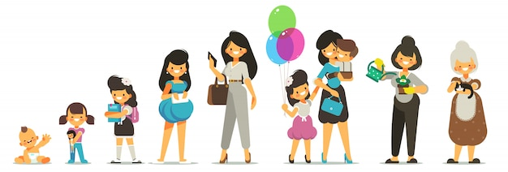
History Timeline

Patterns of codependency + Patterns of healthy behavior

Infant to 5 Years

5 Years to 12 Years

12 Years to 18 Years

18 Years to 22 Years

22 Years to 30 Years

30 Years to 40 Years

40 Years to 50 Years

40 Years to 60 Years

Denial Patterns
Codependents often... | How I HURT MYSELF |  |  | How I HURT OTHERS |  |  | In recovery...
Have difficulty identifying what they are feeling. |  |  |  |  |  |  | I am aware of my feelings and identify them, often in the moment. I know the difference between my thoughts and my feelings.
Minimize, alter, or deny how they truly feel. |  |  |  |  |  |  | I embrace my feelings; they are valid and important.
Perceive themselves as being completely unselfish and dedicated to the well-being of others. |  |  |  |  |  |  | I know the difference between caring and caretaking. I recognize that caretaking others is often motivated by the need to benefit myself.
Lack empathy for the feelings and needs of others. |  |  |  |  |  |  | I am able to feel compassion for another's feelings and needs
Label others with their negative traits. |  |  |  |  |  |  | I acknowledge that I may own the negative traits I often perceive in others.
Think they can take care of themselves without any help from others. |  |  |  |  |  |  | I acknowledge that I sometimes need the help of others.
Mask pain in various ways such as anger, humor, or isolation. |  |  |  |  |  |  | I am aware of my painful feelings and express them appropriately.
Express negativity or aggression in indirect and passive ways. |  |  |  |  |  |  | I am able to express my feelings openly, directly, and calmly.
Do not recognize the unavailability of those people to whom they are attracted. |  |  |  |  |  |  | I pursue intimate relationships only with others who want, and are able to engage in, healthy and loving relationships.
Low Self-Esteem Patterns
Codependents often... |  | How I HURT MYSELF |  |  | How I HURT OTHERS |  |  | In recovery...
Have difficulty making decisions. |  |  |  |  |  |  |  | I trust my ability to make effective decisions.
Judge what they think, say, or do harshly, as never good enough. |  |  |  |  |  |  |  | I accept myself as I am. I emphasize progress over perfection.
Are embarrassed to receive recognition, praise, or gifts. |  |  |  |  |  |  |  | I feel appropriately worthy of the recognition, praise, or gifts I receive
Value others' approval of their thinking, feelings, and behavior over their own. |  |  |  |  |  |  |  | I value the opinions of those I trust, without needing to gain their approval. I have confidence in myself.
Do not perceive themselves as lovable or worthwhile persons. |  |  |  |  |  |  |  | I recognize myself as being a lovable and valuable person.
Seek recognition and praise to overcome feeling less than. |  |  |  |  |  |  |  | I seek my own approval first, and examine my motivations carefully when I seek approval from others.
Have difficulty admitting a mistake. |  |  |  |  |  |  |  | I continue to take my personal inventory, and when I am wrong, promptly admit it.
Need to appear to be right in the eyes of others and may even lie to look good. |  |  |  |  |  |  |  | I am honest with myself about my behaviors and motivations. I feel secure enough to admit mistakes to myself and others, and to hear their opinions without feeling threatened.
Are unable to identify or ask for what they need and want. |  |  |  |  |  |  |  | I meet my own needs and wants when possible. I reach out for help when it's necessary and appropriate.
Perceive themselves as superior to others. |  |  |  |  |  |  |  | I perceive myself as equal to others.
Look to others to provide their sense of safety. |  |  |  |  |  |  |  | With the help of my Higher Power, I create safety in my life.
Have difficulty getting started, meeting deadlines, and completing projects. |  |  |  |  |  |  |  | I avoid procrastination by meeting my responsibilities in a timely manner.
Have trouble setting healthy priorities and boundaries. |  |  |  |  |  |  |  | I am able to establish and uphold healthy priorities and boundaries in my life.
Compliance Patterns
Codependents often... |  |  | How I HURT MYSELF |  |  | How I HURT OTHERS |  |  | In recovery...
Are extremely loyal, remaining in harmful situations too long. |  |  |  |  |  |  |  |  | I am committed to my own safety and leave situations that feel unsafe or are inconsistent which my goals.
Compromise their own values and integrity to avoid rejection or anger. |  |  |  |  |  |  |  |  | I am rooted in my own values, even if others don't agree or become angry.
Put aside their own interests in order to do what others want. |  |  |  |  |  |  |  |  | I consider my interests and feelings when asked to participate in another's plans.
Are hypervigilant regarding the feelings of others and take on those feelings. |  |  |  |  |  |  |  |  | I can separate my feelings from the feelings of others. I allow myself to experience my feelings and others to be responsible for their feelings.
Are afraid to express their beliefs, opinions, and feelings when they differ from those of others. |  |  |  |  |  |  |  |  | I respect my own opinions and feelings and express them appropriately.
Accept sexual attention when they want love. |  |  |  |  |  |  |  |  | My sexuality is grounded in genuine intimacy and connection. When I need to feel loved, I express my heart's desires. I do not settle for sex without love.
Make decisions without regard to the consequences. |  |  |  |  |  |  |  |  | I ask my Higher Power for guidance and consider possible consequences before I make decisions.
Give up their truth to gain the approval of others or to avoid change. |  |  |  |  |  |  |  |  | I stand in my truth and maintain my integrity, whether others approve or not, even if it means making difficult changes in my life.
Control Patterns
Codependents often... |  |  | How I HURT MYSELF |  |  | How I HURT OTHERS |  |  | In recovery...
Believe most other people are incapable of taking care of themselves. |  |  |  |  |  |  |  |  | I realize that, with rare exceptions, other adults are capable of managing their own lives.
Attempt to convince others what to think, do, or feel. |  |  |  |  |  |  |  |  | I accept the thoughts, choices, and feelings of others, even though I may not be comfortable with them.
Freely offer advice and direction without being asked. |  |  |  |  |  |  |  |  | I give advice only when asked.
Become resentful when others decline their help or reject their advice. |  |  |  |  |  |  |  |  | I am content to see others take care of themselves.
Lavish gifts and favors on those they want to influence. |  |  |  |  |  |  |  |  | I carefully and honestly contemplate my motivations when preparing to give a gift.
Use sexual attention to gain approval and acceptance. |  |  |  |  |  |  |  |  | I embrace and celebrate my sexuality as evidence of my health and wholeness. I do not use it to gain the approval of others.
Have to feel needed in order to have a relationship with others. |  |  |  |  |  |  |  |  | I develop relationships with others based on equality, intimacy, and balance.
Demand that their needs be met by others. |  |  |  |  |  |  |  |  | I find and use resources that meet my needs without making demands on others. I ask for help when I need it, without expectation.
Use charm and charisma to convince others of their capacity to be caring and compassionate. |  |  |  |  |  |  |  |  | I behave authentically with others, allowing my caring and compassionate qualities to emerge.
Use blame and shame to exploit others emotionally. |  |  |  |  |  |  |  |  | I ask directly for what I want and need and trust the outcome to my Higher Power. I do not try to manipulate outcomes with blame or shame.
Refuse to cooperate, compromise, or negotiate. |  |  |  |  |  |  |  |  | I cooperate, compromise, and negotiate with others in a way that honors my integrity.
Adopt an attitude of indifference, helplessness, authority, or rage to manipulate outcomes. |  |  |  |  |  |  |  |  | I treat others with respect and consideration, and trust my Higher Power to meet my needs and desires.
Use recovery jargon in an attempt to control the behavior of others. |  |  |  |  |  |  |  |  | I use my recovery for my own growth and not to manipulate or control others.
Pretend to agree with others to get what they want. |  |  |  |  |  |  |  |  | My communication with others is authentic and truthful.
Avoidance Patterns
Codependents often... |  |  | How I HURT MYSELF |  |  | How I HURT OTHERS |  |  |  | In recovery...
Act in ways that invite others to reject, shame, or express anger toward them. |  |  |  |  |  |  |  |  |  | I act in ways that encourage loving and healthy responses from others.
Judge harshly what others think, say, or do. |  |  |  |  |  |  |  |  |  | I keep an open mind and accept others as they are.
Avoid emotional, physical, or sexual intimacy as a way to maintain distance. |  |  |  |  |  |  |  |  |  | I engage in emotional, physical, or sexual intimacy when it is healthy and appropriate for me.
Allow addictions to people, places, and things to distract them from achieving intimacy in relationships. |  |  |  |  |  |  |  |  |  | I practice my recovery to develop healthy and fulfilling relationships
Use indirect or evasive communication to avoid conflict or confrontation. |  |  |  |  |  |  |  |  |  | I use direct and straightforward communication to resolve conflicts and deal appropriately with confrontations.
Diminish their capacity to have healthy relationships by declining to use the tools of recovery. |  |  |  |  |  |  |  |  |  | When I use the tools of recovery, I am able to develop and maintain healthy relationships of my choosing.
Suppress their feelings or needs to avoid feeling vulnerable. |  |  |  |  |  |  |  |  |  | I embrace my own vulnerability by trusting and honoring my feelings and needs.
Pull people toward them, but when others get close, push them away. |  |  |  |  |  |  |  |  |  | I welcome close relationships while maintaining healthy boundaries.
Refuse to give up their self-will to avoid surrendering to a power greater than themselves. |  |  |  |  |  |  |  |  |  | I believe in and trust a power greater than myself. I willingly surrender my self-will to my Higher Power.
Believe displays of emotion are a sign of weakness. |  |  |  |  |  |  |  |  |  | I honor my authentic emotions and share them when appropriate.
Withhold expressions of appreciation. |  |  |  |  |  |  |  |  |  | I freely engage in expressions of appreciation toward others.

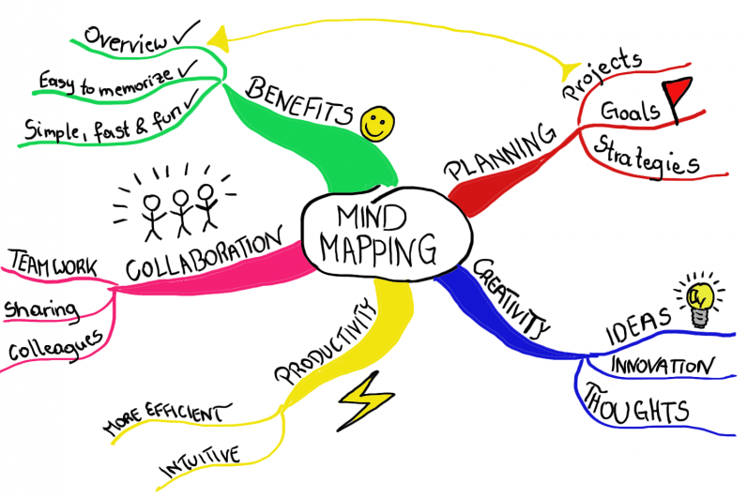
Fourth Step Chart (from the CoDA Book)

Person | My codependent behavior & reactions |  | My feelings that drove those behaviors |  | Consequences to the person, myself & the relationship |  | My feelings about my behavior & consequences
Positive Attributes Chart

Attribute |  | Action or Behavior |  | Feeling |  | Progress in Recovery

List of positive qualities & characteristics
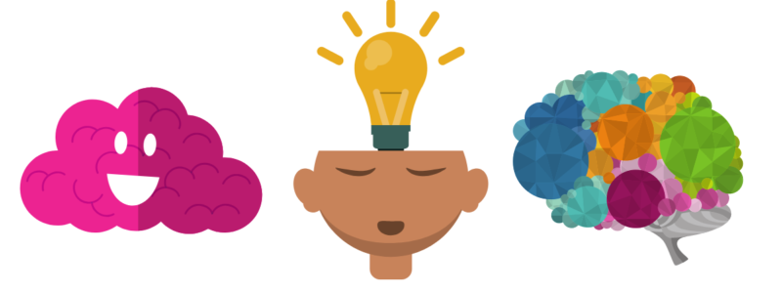
List of positive qualities & characteristics, there are many many more. Here is a list of some of them:

- Accurate
- Adventurous
- Ambitious
- Appreciative
- Artistic
- Assertive
- Attentive
- Bold
- Capable
- Caring
- Charming
- Clean
- Clever
- Consistent
- Constructive
- Convincing
- Cooperative
- Courageous
- Courteous
- Creative
- Curious
- Decisive
- Dependable
- Easygoing
- Educated
- Efficient
- Enthusiastic
- Ethical
- Experienced
- Fashionable
- Fit
- Forgiving
- Frank
- Friendly
- Funny
- Gentle
- Grateful
- Hard-working
- Helpful
- Honest
- Humane
- Humble
- Imaginative
- Independent
- Individualistic
- Interesting
- Inventive
- Kind
- Likable
- Logical
- Loyal
- Mature
- Methodical
- Modern
- Modest
- Motivated
- Neat
- Observant
- Open-minded
- Patient
- Perceptive
- Polite
- Positive
- Practical
- Productive
- Proficient
- Progressive
- Prompt
- Punctual
- Purposeful
- Quick
- Realistic
- Reasonable
- Relaxed
- Reliable
- Resilient
- Resourceful
- Respectful
- Responsible
- Romantic
- Self-confident
- Self-disciplined
- Self-reliant
- Sensitive
- Serious
- Shows initiative
- Strong
- Suave
- Supportive
- Talented
- Thoughtful
- Thrifty
- Trustworthy
- Unselfish
- Versatile
- Warm
- Wholesome
- Willing
- Wise

